Wireshark Lab 4-2

202022300317 杨业昶

## Step 1: Fetch a Trace

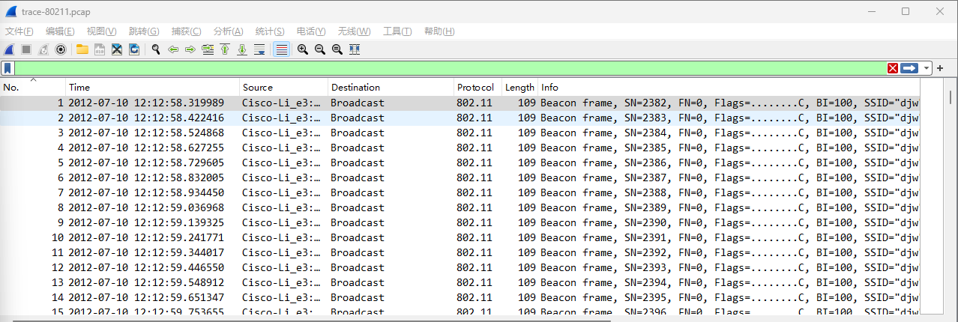

## Step 2: Inspect the Trace

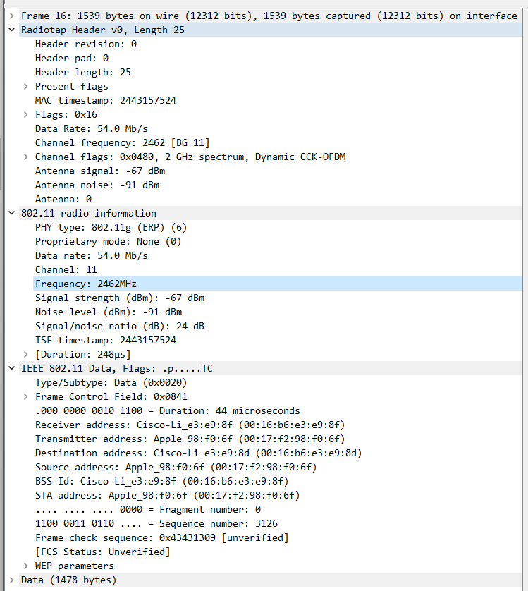

## Step 3: 802.11 Physical Layer

What is the channel frequency?

>>> 2462MHz

What rates are used?

>>> Data rate: 54.0Mb/s

What is the range of RSSI and hence variation in SNRs in the trace?

>>> RSSI: -67dBm~-44dBm; SNR: 21dB~47dB

## Step 4: 802.11 Link Layer

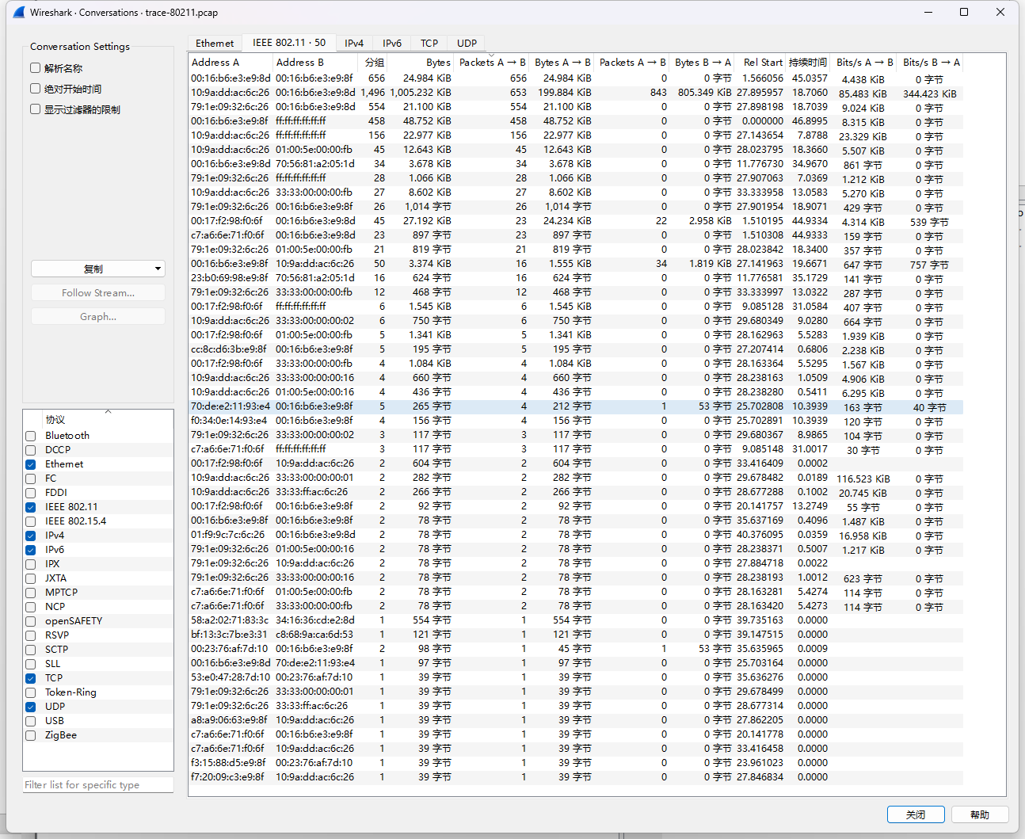

What is the BSS ID used by the most active wireless conversations?

>>> Cisco-Li_e3:e9:8d

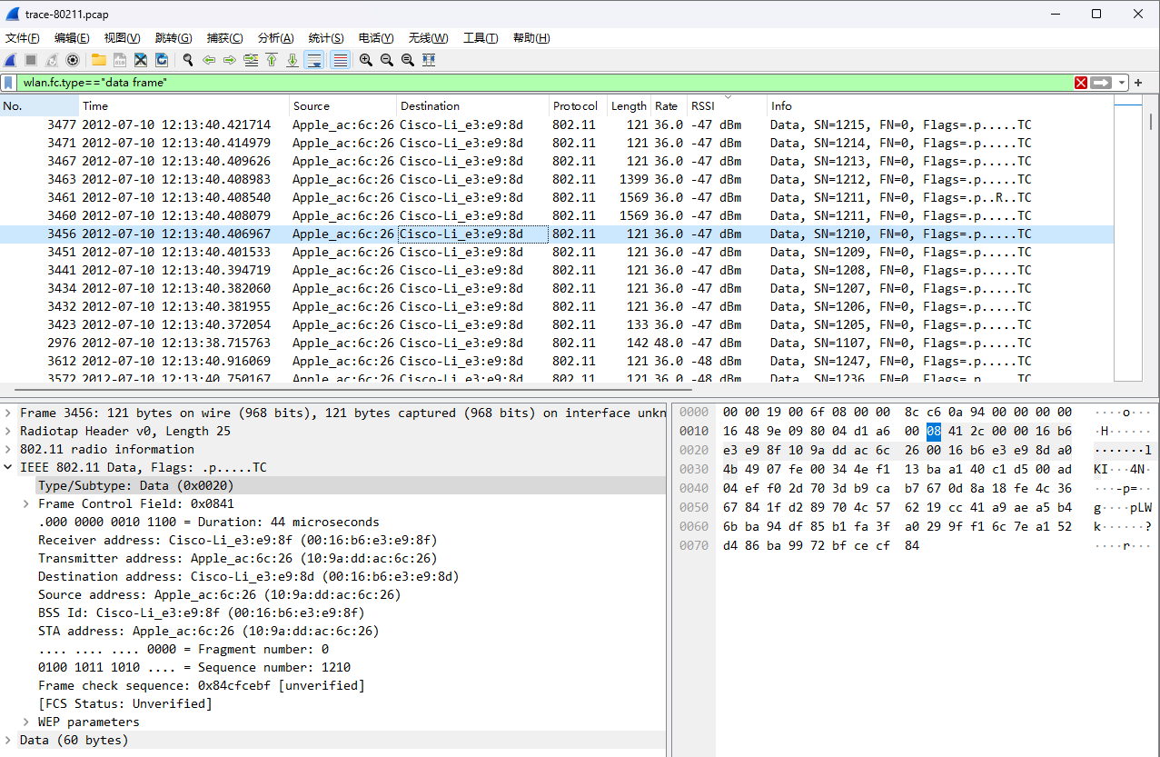

How many Data frames are in the trace, and what is the most common subtype of Data frame?

>>> 1783; Type/Subtype: Data (0x0020)

How many Control frames are in the trace, and what is the most common subtype?

>>> 1391; Type/Subtype: Acknowledgement (0x001d)

How many Management frames are in the trace, and what is the most common subtype?

>>> 557; Type/Subtype: Beacon frame (0x0008)

List in the order they are sent the IEEE 802.11 fields in an Acknowledgement frame and their lengths in bytes.

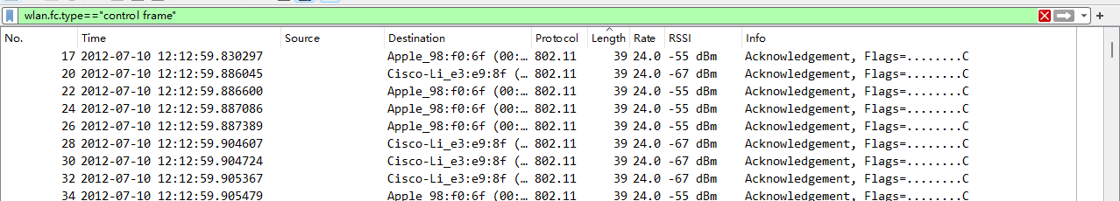

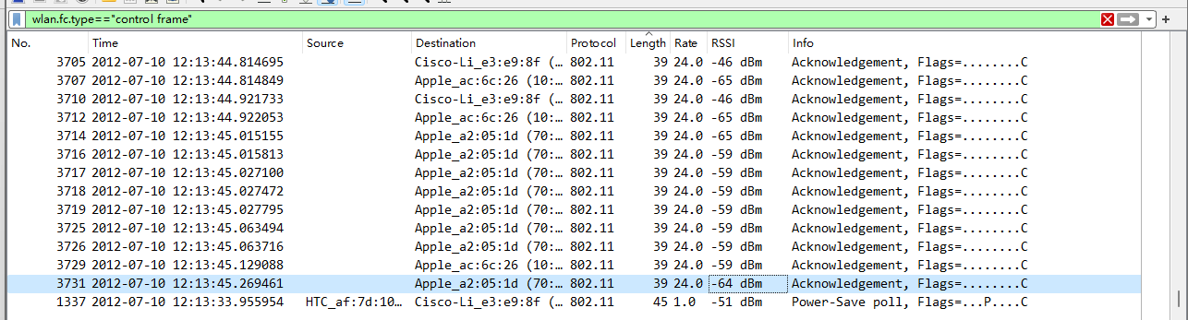

>>> Length: 39bytes

Give an estimate of the retransmission rate as the number of retransmissions over the number of original transmissions. Show your calculation.

>>> retransmission rate = retransmissions / original transmissions = 353/1430 ~= 24.7%

What fraction of the frames sent to the AP signal that the client is powering down?

>>> 16

## Step 5: 802.11 Management

What is the SSID of the main AP?

>>> BSS Id: Cisco-Li_e3:e9:8f (00:16:b6:e3:e9:8f)

How often are Beacon frames sent for the main AP?

>>> 0.102s

What data rates does the main AP support?

>>> 1.0Mb/s 6.0Mb/s 12.0Mb/s 18.0Mb/s 24.0Mb/s 36.0Mb/s 48.0Mb/s 54.0Mb/s

What rate is the Beacon frame transmission?

>>> 1.0Mb/s

What are the Type and Subtype values of Association Request / Association Response frames?

>>> Association Request (0x0000) / Association Response (0x0001)

What are the Type and Subtype values for the Probe Request / Probe Response frames?

>>> Probe Request (0x0004) / Probe Response (0x0005)